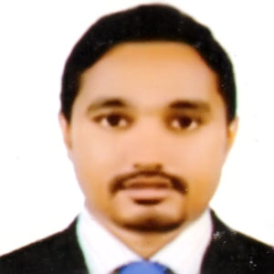
Resume
Of
MD. SHARIFULL ISLAM
Mobile: 01922855636, 01671914909

Email- sharifullshapon@gmail.com

Career Objectives:

Want to build up my career as a keen official for public or private sectors, where punctuality, sincerity and creatively are always appreciated.

WORKING EXPERENCE:
Organization : Runner Automobils Limited
Position : COCO Manager
Location : 138/1 Tejgaon I/A , Dhaka-1208.
Working Period : 1st November 2015 To Present
Responsibility : Follow up Sales Our Product And Collection, Reporting to the
Management of total data, Marketing, And Visit Customer,
Instant Problem Sover, Relationship With Customer

Training : Secret Of Hard Selling of SHARPENER, 3rd April-2019

EDUCATION QUALIFICATION:
Masters:
Institute : Dhaka College, Dhaka.
Result : 2nd Class
Passing Year : 2013
Subject : Bangla
Board : National University

Honors:
Institute : Dhaka College, Dhaka.
Result : 3rd Class
Passing Year : 2012
Subject : Bangla
Board : National University

Higer Secondary Certificate (H.S.C)
Institute : Rajarbag police line College
Result : 3.00 (Out of 5.00)
Passing Year : 2008
Subject : Commerce
Board : Dhaka

Secondary School Certificate (S.S.C)
Institute : Ali Ahmed High School
Result : 4.00 (Out of 5.00)
Passing Year : 2008
Subject : Commerce
Board : Dhaka

Computer Skills:
Operating capacity in windows XP, Seven (7) and next versions &
MS office programs including word processing,Excel, Internet browsing.

Language Proficiency: Have a good writing and speaking command in Bengali and English language.

Skill and Attributes:

1. Absolutely positive hard working with a positive attitude.
2. Resourceful effective communication skill.
3. Work independently and as a team member.
4. Handle high pressure situation and deadlines.
5. Effective in maintaining good communication with other etc.

Personal Details:

Name : MD. Sharifull Islam
Father’s Name : MD. Ali Akbar
Mother’s Name : Sufia Parvin
Current Address : Kolakopa, Nawabgonj, Dhaka-1320

Permanent Address : Vill : Khaliya, Post : Binodpur, Thana : Mohammodpur , District : Magura
Date of birth : 01/01/1991
Nationality : Bangladeshi (by birth)
Religion : Islam
Marital Status : Married
Contact No : 01922855636 / 01671914909

I declare hereby that all information I have presented so far are true to my knowledge. If required and where applicable, this document can be supported by authentic certificates/papers.

MD. Sharifull Islam
Date :

